Debbie Ming-Mendoza

Democrat for County Clerk

2014 General Election Campaign plan

Sherry Price, Price-Miner Creative Strategies

**Situation**

Debbie Ming-Mendoza is a long-time public servant whose career in Madison County Government includes 39 years in the assessor’s office. She rose to become the head of that office in 1995. In 2012, Debbie was appointed Madison County Clerk. Now, in 2014, she is running for election to a full term. While an active Democrat, Debbie is primarily known for her professionalism and integrity in managing these two sensitive offices where voters prize independence and where there is no room for favoritism or politics. As assessor, Debbie had an impressive record of never having a state equalizer (multiplier) applied to Madison County. And, although she has not been elected county clerk in her own right, Debbie has successfully overseen two elections with no controversy or issues.

Republican County Board member Steve Adler from the Godfrey area opposes Debbie. Adler is a retired head of maintenance for the State of Illinois. Adler says he is now self-employed, managing investments. Although a Republican, Adler chairs the Buildings and Lands committee and serves on Personnel and Labor Relations. Adler is not connected to the conservative, Tea Party wing of the Republican Party, but he has allied with Republican officeholder Kurt Prenzler in criticizing misdeeds by Democrat officeholders, especially Fred Bathon, and in loudly decrying Democrat “corruption.” This message was very successful in 2010 when Republicans won two offices from Democrat appointees, putting Prenzler into the Treasurer’s Office and Matt Rice in the Recorder’s office. Rice subsequently lost his election to a full term in 2012.

It is critical to understand how different Madison County is in a presidential and a non-presidential year. In 2012, 123,834 people voted. In 2010, only 83,208 voted. Not only were the vote totals smaller, the partisanship ratios become closer. As population has declined in the once-powerful Route 3 industrial corridor and risen in the bedroom communities that attract St. Louis commuters, the victory margins in contested races for Democrats have declined. In 2010, in the three contested county races, Republicans won two and the Democrat incumbent sheriff showed poorly against an opponent who literally did nothing but put his name on the ballot. This was the culmination of years of changing demographics in the county. By contrast, in 2012, in a presidential year, Democrats swept contested offices in the county in spite of a poor showing from an unpopular Democrat president who failed to win the county and was a drag on the ticket. Judge Kyle Napp, a Price-Miner client, led contested Democrats with 57% of the vote. President Obama held the bottom with 49%.

The bottom line is that Democrat voters turn out in presidential years in far greater numbers, allowing Democrats to win with comfortable margins - although those margins are declining.

One tactic being pursued by the Senate Democrats in support of U.S. Senator Richard Durbin and which the Madison County Democrat Party is reportedly pursuing is to try to persuade Democrat-leaning voters who don’t vote in off-year elections to come out this year. There is little down-ballot candidates like county officials can do to excite and turn out these voters, but it will be interesting to see if this effort behind a contested Senate and contested gubernatorial race will be able to add potential Democrat-leaning voters to the universe of voters.

Classically, campaigns focus on likely voters, breaking them down by partisanship and persuadability. However, ever since Karl Rove successfully pioneered a strategy in Ohio in 1994 of shifting resources to turning out less likely voters rather than expend more dollars chasing the same small pool of undecided voters there, strategists have looked for opportunities to add votes by expanding the universe of voters in an election. In the primaries this year, Thad Cochran defeated a Tea Party opponent and David Brat defeated House Majority Leader Eric Cantor by turning out unexpected voters. Shockingly, Brat turned out more Republicans in a non-presidential year primary than typically turn out in a presidential year primary. Cochran turned to African-American Democrat voters to come out in a Republican primary run-off election. Locally, in Madison County, disaffected police officers who had never voted in a Democrat primary before turned out to pad the victory margin of John Lakin (a Price-Miner client) over incumbent Bob Hertz. While Lakin would have won without those votes, his margin would have been much tighter. Clearly, given the results this year, the Ming-Mendoza campaign should factor in this effort into its voter contact and advertising strategy – with the caveat not to focus too much of its own limited resources on this unlikely source of new voters.

**The match-up: message**

Adler already is aggressively working precincts with a troublesome message. He is blaming Debbie as the assessor for high taxes in Madison County. He also is using tax information obtained from Kurt Prenzler to urge residents to challenge their tax assessments, telling them that Debbie and the assessor’s office incorrectly assessed their properties – especially by not giving them appropriate deductions. About a dozen people have contacted the Madison County Assessor’s Office to raise these issues. In each case to date, the information given the resident has been wrong. Adler also is clearly setting up a message in coordination with Prenzler that voters should choose Republicans to counter either outright Democrat corruption or a willingness to turn a blind eye to other corrupt officials. The combination of taxes and corruption could be a powerful message for Adler if he can deliver it. The assessment of observers is that Adler will have limited resources to fund his campaign, but he is good at generating free media coverage for his charges and he clearly is willing to personally work. Allying with Prenzler who is expected to have more money and more supporters also could give him the opportunity to more broadly deliver his message. A coordinated Republican campaign on these lower-level offices would benefit from recent scandals involving Sheriff Bob Hertz and former Treasurer Fred Bathon.

It seems likely that Adler will pay close attention to the strategy pursued by Prenzler over two elections to win the treasurer’s office. The Prenzler strategy against Bathon in 2006 was to relentlessly attack, constantly pressing Bathon. Bathon (a Price-Miner client) fended off the attacks with both aggressive counterattacks and an innovative cable television strategy to turn his perceived personal negatives into positives. These successful ads fended off Prenzler’s attacks, as well as mitigated some self-inflicted damage. Prenzler actively worked a network of evangelical voters, using message boards and early social media efforts. In 2010, Prenzler built on his previous campaign to win the treasurer’s office against Frank Miles.

It can be anticipated that Adler will manage to raise enough money for signs and, likely, some amount of direct mail. He also is likely to actively use free media, social media, and direct voter contact to deliver a series of negative attacks. The nature of negative attacks makes them easier to deliver in lower cost ways as it takes less frequency for voters to notice and absorb them. We already have seen Adler make the false charge that somehow Debbie is responsible for individual homeowners paying too much in property taxes. While information is anecdotal, this attack has the potential to be highly effective. This charge can be spread by his strategy of working a handful of precincts across Madison County communities of Alton, Wood River, Granite City, and Edwardsville.

For Debbie, we recommend she aggressively counter any negative charges in whatever medium they are delivered (free media, social media, direct contact, etc.) Although an officeholder, Debbie is not a household name. This fact makes her vulnerable to an opponent defining her negatively before she can define herself positively. In the case of the charges on her record as assessor, we recommend a strong counterattack using free media, charging her opponent and Prenzler with playing politics with people’s personal tax information. We also recommend a paid communications strategy touting her professional, non-partisan record as assessor. For Debbie, it will be critical for her to move quickly to define herself and her own record before her opponents define her in broad strokes as a corrupt Democrat.

As assessor and, now, as county clerk, Debbie has held positions where voters value a professional, independent and non-partisan approach. There is nothing wrong with her being a life-long Democrat who espouses Democrat values, but the way she operates her office must be more non-partisan. Her models should definitely be Evelyn Bowles and Eulalia Hotz, two strong, independent women who earned the trust of the voters. They were active Democrats, but held themselves out as being a little separate from the Party organization – something befitting the officials overseeing the election process.

We recommend Debbie embrace the nature of her office with all of its democratic and patriotic trappings. What better counter to the charges of cynicism and corruption or to the corrosive nature of a negative campaign than the cheerful optimism natural to Debbie and appropriate to her office. All of her campaign messages should include an appeal to good citizenship and an honest sense of the responsibility of being the steward of our democratic system. She should embrace being the **county’s chief democracy officer.**

The other challenge or issue for Debbie is being a woman candidate running against a man. There is a huge gender gap between the partisanship of men and women with the Republican Party being majority men and the Democratic Party being major women. Happily, women also outnumber men as voters. This is potentially an advantage for Debbie. However, women traditionally must overcome a qualifications hurdle (especially with fellow women voters) that men normally do not have to overcome. Once a woman candidate overcomes that hurdle, she often can attract women in large numbers to her campaign. In this instance, Debbie is a clearly more qualified and professional candidate than her opponent.

Our argument must be that Debbie has been a successful, professional public servant as both assessor and, now, county clerk. Her opponent was a “maintenance engineer” whose only government service has been political – as a county board member. Debbie needs to be positioned as the independent, professional, steward of democracy while portraying Adler as a politician whose negative attacks are just so much political B.S. Using voters personal tax data for political purposes is a good example – especially when he is using it to give voters false information about their ability to lower their tax assessments.

We need to define Debbie as a sincere public servant and professional with no taint of scandal or corruption before she is caught up in general attacks by Republicans to throw out corrupt and incompetent Democrats from Quinn down to the county level.

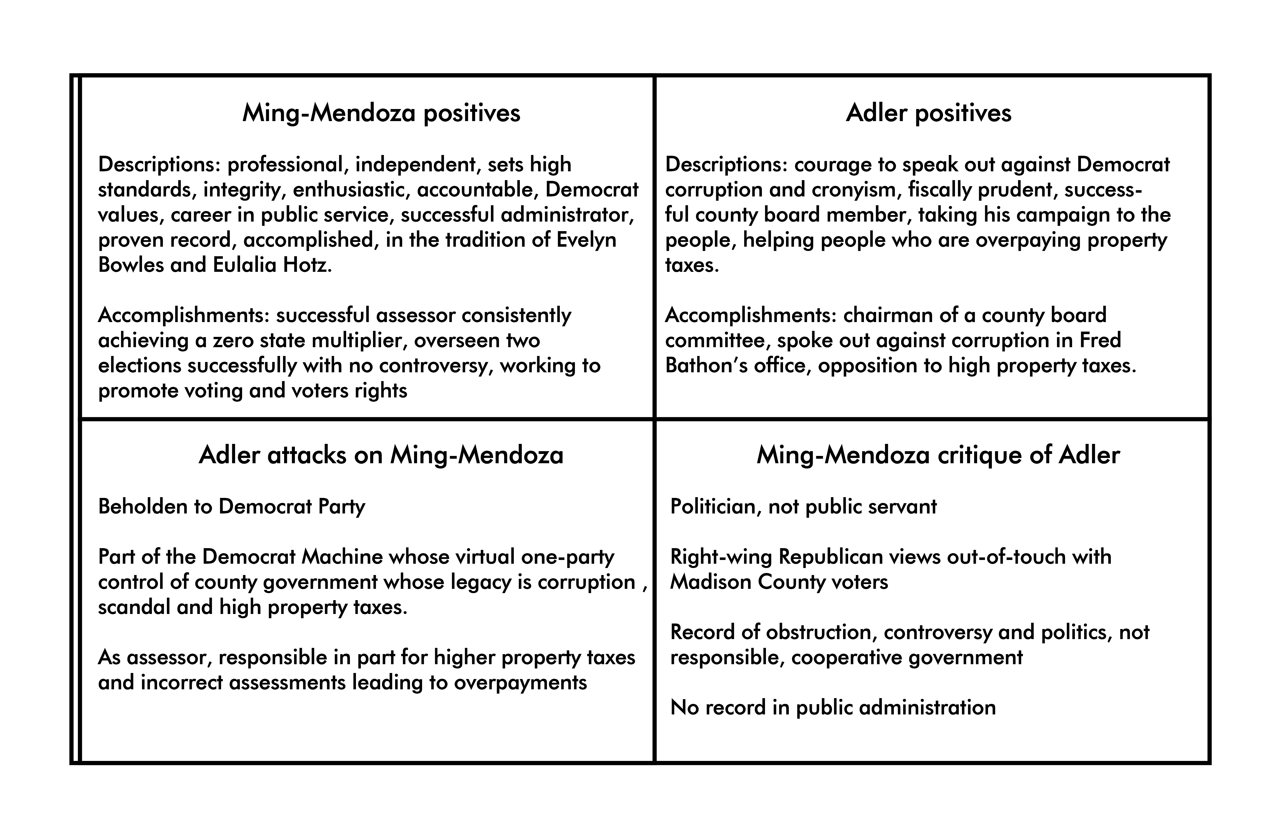

Looking at the message box, the contrast between Ming-Mendoza and Adler is clear: public servant versus politician and a record of successful, non-partisan administration versus controversy, obstructionism and politics. However, it also seems clear that more work needs to be done to strengthen the critique of Adler. We suggest looking more closely at his votes and his actions on the county board.

Based on the positives in the message box, the slogan “A proven record of integrity accountability and independence” sums up her successful administration of two offices as well as the portrait of her as an independent professional in contrast to the image of corruption the Republicans will use to attempt to tar Democrats in this cycle.

**Delivering the message**

For voters to, first, remember a candidate’s name and then, second, absorb a candidate’s message requires multiple contacts. All contacts require some expenditure of resources. Some of these contacts primarily “cost” time, people and candidate resources and some “cost” larger dollar amounts.

Here is a review of the elements of Debbie’s campaign tactics.

**Voter contact**

There are multiple methods for contacting voters directly – all of which should be part of Debbie’s campaign plan.

Door-to-door. Debbie and a support team should begin going door-to-door in August, with larger groups of volunteers joining after Labor Day. Debbie should begin with her likely base of support in the Tri-Cities, then build out to strong Democrat precincts in the north part of the county (WR, Alton, East Alton, Bethalto, Roxana, Hartford, etc.). Working the precincts with the highest number of Democrat voters first will allow Debbie to secure the support of voters who really just need to know her name and her party identification to support her. It also allows the campaign to identify yard sign locations and potential future volunteers. From there, Debbie should work key swing precincts, many of which are located along Route 159 from Edwardsville to Collinsville. As the volunteers join the effort, the campaign can expand and work all but the most Republican-leaning precincts.

Volunteer and paid phone banks. After Labor Day, the campaign can begin an effort to follow up on precinct walks with volunteer phone banks, with volunteers attempting to identify and record supportive voters to put into the GOTV effort. As the campaign moves along, it may elect to use a paid phone bank to expand its efforts and complete its precincts.

Friend-to-friend cards. While Facebook has in many ways displaced friend-to-friend cards or friends and families campaigns, this is an inexpensive tactic for increasing the value of a campaign’s supporters and should be considered as the campaign proceeds.

Voter contact should provide two to three contacts into key households.

**Advertising**

For most Metro-East campaigns in an area dominated by St. Louis media, campaigns traditionally use in some combination cable television, direct mail, social media (Facebook, Google, Yahoo, etc.), digital media (web sites), and yard signs and billboards. At times, local radio (WBGZ in Alton) and local newspapers can be utilized for specific messages. Well-financed, hard-fought campaigns often buttress these local tactics with St. Louis television and radio.

Advertising is usually evaluated by two measures: reach and frequency – that is how large a group is effectively reached and how many times. Media planners then look at the cost of achieving these two measures.

In general election campaigns (as opposed to primaries with their comparatively small audience), the most cost effective form of advertising is cable television supported by social media and yard signs. This, of course, is reversed in primaries due to the small overall voting universe where direct mail supported by social media and yards signs is most cost-effective. The cost of delivering one mail piece per household to likely voters in Madison County in a non-presidential year is approximately $18,000. A good direct mail campaign will be looking to mail four to five mail pieces at a cost of $72,000 to $90,000. A strong cable advertising campaign in Madison County will cost roughly $50,000 with production of commercials included. The direct mail campaign will have a larger reach, but the cable advertising campaign will have more frequency. It is not uncommon for campaigns to blend these with a strong cable campaign supported by perhaps one or two targeted mailings. Also, social media and yard signs provide very cost-effective ways to multiply the impact of the campaigns.

There is an additional way to look at advertising and that is impact. Television and radio are active forms of advertising, meaning that the message hits the audience between the eyes without requiring any action on their part. Direct mail and print advertising are passive, meaning that the advertising itself is not active, requiring the audience to choose to engage with it by reading. So, although direct mail can be delivered to every household, the total number of potential voters who will choose to engage with it before dropping it in the trash can is much, much smaller. This audience becomes even smaller when a message is placed into an envelope with requires opening. The bottom line is that when a television campaign hits, it moves polling numbers in short order. It is much more difficult to move polling numbers by direct mail.

For campaigns in more than one county, such as appellate or Supreme Court campaigns, St. Louis television itself becomes the most cost-effective approach and has been the key to successful Price-Miner campaigns for Harrison, Chapman, Stewart, Wexxsten, Cates and others.

For more than 20 years, Price-Miner candidates have been very successful by emphasizing television campaigns. In St. Clair County, Mark Kern has been using cable since he ran for the mayor of Belleville and contested races for candidates like Jennifer Gomric-Minton have followed suit. In Madison County, Price-Miner has focused on cable television for winning campaigns for Hoffman, Callis, Napp, Crowder, retention judge elections, and many more.

We again recommend that cable television be the basis for the Ming-Mendoza campaign, supported by social media, digital media, and yard signs. If the campaign can raise enough money, we would consider adding a targeted mail piece. There is one issue with cable television in Madison County. Collinsville is included in the St. Clair County zone. We will need to develop a Collinsville campaign to make up for this issue. This is likely to be some added direct mail here. Cable advertising is cheapest early in a campaign and becomes more expensive closer to the election. In addition, commercials at the end of a campaign are often in fierce competition with many other commercials. We recommend an early start to the advertising, even in late August if the campaign can develop the funding in time.

We see no geographic needs at this time that would require newspaper, Alton radio or billboards, but will continue to evaluate as the campaign proceeds and resources become available.

One item to consider as the campaign builds its resources is to add women-oriented St. Louis radio. This can be a nice way to affordably add advertising frequency to a key demographic.

Advertising should be able to provide four to five contacts into key households.

**Polling**

Price-Miner pioneered the use of polling more than 20 years ago in the Metro-East area as a way to test and develop message. Given the cost of polling, we do not currently recommend polling for this campaign, although we will wish to re-evaluate this as the campaign proceeds. Various party and candidate coalitions have polled in the past, but these polls efforts are often flawed and designed in a way to provide limited value. Before participating in any of these polls, we would want some say in their design and methodology.

**Draft budget**

**Essentials (total)** $71,000

Walk piece and other handout materials and door-to-door support 3500

Phoning (not including paid phoning at this time) donated

Yard signs 3000

Web site 3500

Social and digital media advertising 3500

Cable television (ad time and production) 50,000

Price-Miner Consulting fees July-Nov 7,500

**Additionals to be considered**

One mail piece $18,000

Targeted mail to women, independent voters $12,000